21BDS0340

Abhinav Dinesh Srivatsa

Question 81

Electrical Lab FAT

# Maximum Power Transfer Theorem

## Aim:

To find the maximum power dissipated in the load resistor.

## Apparatus:

ORCAD / Capture CIS: Analog Library – R

Source Library – Vdc, Idc

Ground (GND) – 0 (zero)

Simulation Settings: Analysis Type – DC Sweep

## Statement:

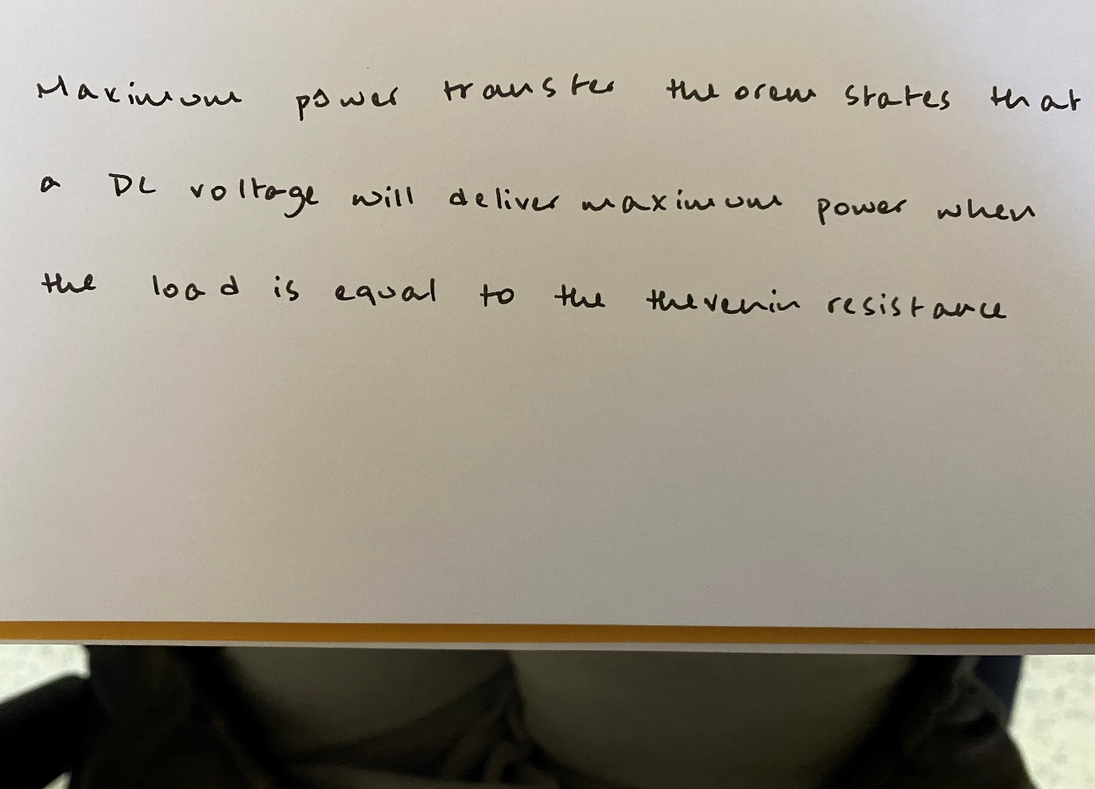

## Manual Calculations:

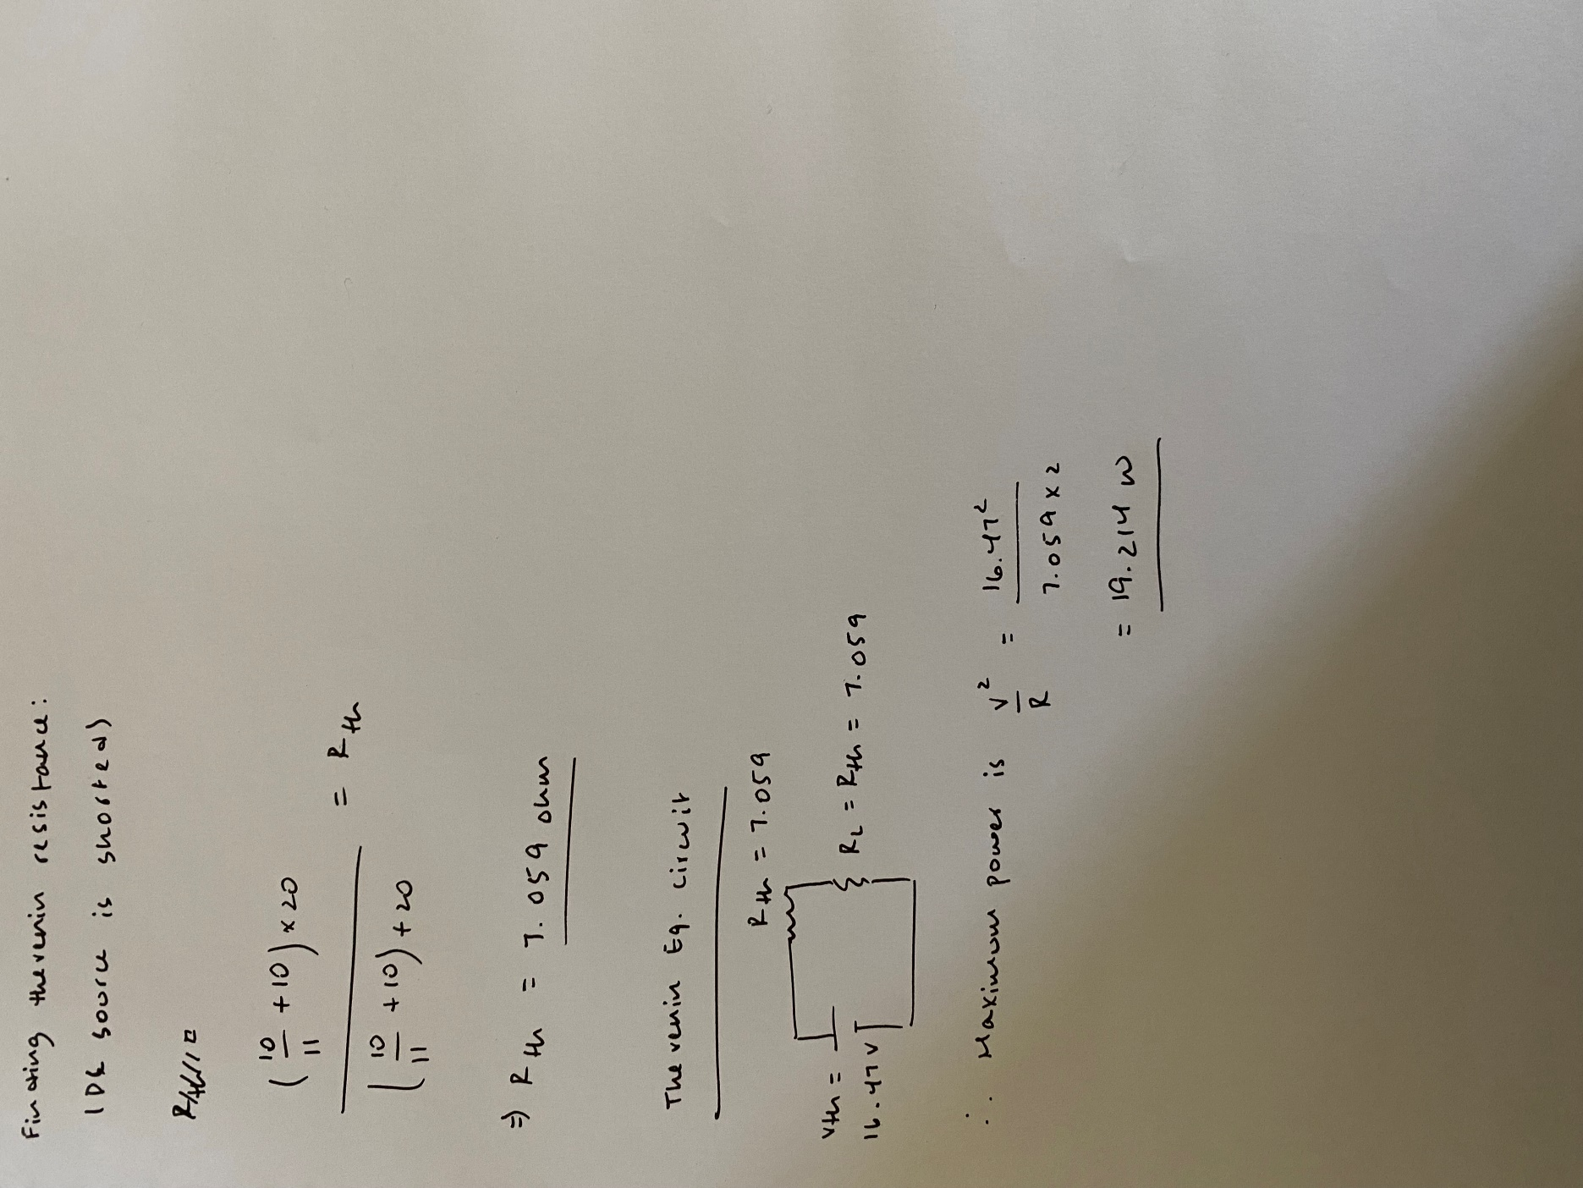

**Max power with both resistors = 19.214 watts**

**For load resistance only = 9.607 watts**

## Simulation Circuit:

## Result:

### Resistance Value vs. Power Graph

### Chart, line chart Description automatically generatedZoomed in value of maximum power

|  |  |  |
| --- | --- | --- |
| Notation | Manual Calculations | Simulated Result |
| Rth | 7.059 | 7.0588 |
| Pmax | 9.607 | 9.608 |

## Inference:

